
<P_AP_ANZ_003_046_CustomerDocket_CityFM>
<Customer Portal - City FM Portal>
Process Design Document (PDD)

Process ID | P_AP_ANZ_03_046_CustomerDocket_CityFM
Business Unit | ANZ
Operation Unit | IT
Process Name | Customer Portal - City FM

Document Version Control
Date Issued | Version | Description/Remark | Attachment | Author
2025-08-04 | 1.0-alpha | Create the document:  - Introduce the background of the process  - Introduce the benefits of the process  - Introduce automated steps of the process |  | DHC - Fan Xiang
2025-08-13 | 1.0-alpha.01 | Add some business details:  - Asset tags matching rules  - Success remind mail format changes  - Set source data file storage link (SharePoint)  - Set key users’ mail group |  | DHC - Fan Xiang
2025-10-28 | 1.0-alpha.02 | Integrate and expand functionality:  - Get source data from City FM Customer Portal  - Navigate to corresponding docket details page in VIEW platform  - Check the docket whether complete or not  - Download docket document from view  - Get key information from docket document  - Maintains related information to work order |  | DHC - Fan Xiang
2025-11-25 | 1.0 | Add some business details:  - Update trigger times and time  - Way to check statuses ‘I’m Complete’, ‘Returning’, ‘Awaiting Parts’.  - Way to check the specific asset tag  - Add Key user list |  | RT- Meng Dana

Contributors
Name | Role
Adsul, Santosh | RPA Process Owner
Lin, Yijia | RPA Service Owner

Document Sign-off Requirements
Name | Department/Partner | Responsibility
Musngi, Jenna | ANZ IT | Review
Mathews, Mary | ANZ IT | Review
Adsul, Santosh | ANZ IT | Sign Off
Lin, Yijia | AP HQ IT | Sign Off

Contents
1 Introduction 5
2 Overview 5
3 Benefits 5
4 Permissions and Authorizations 6
4.1 Robot Permissions 6
5 As-Is Process (Manually) 7
5.1 Process Diagram 7
5.2 Process Description 8
6 To-Be Process (Automated) 9
6.1 Process Diagram 9
6.2 Process Description 10
6.3 Triggers 11
6.4 Target Systems 11
7 Process Details 11
7.1 Get Source Data 11
7.1.1 Login to City FM Portal 11
7.1.2 Retrieve Operation Data 13
7.2 Get Docket Information 14
7.2.1 Login to VIEW Platform 14
7.2.2 Search Docket 15
7.2.3 Download Docket Document 16
7.2.4 Get Key Information from Docket Document 17
7.3 Maintain and Complete the Work Order 18
7.3.1 Work Order Maintenance (City FM) 18
7.4 Execution Report & Remind Mails 19
7.4.1 Generate Execution Report 19
7.4.2 Success Remind Mail 20
7.4.3 Business Exception Remind Mail (No Operation Data) 21
7.4.4 Business Exception Remind Mail (Others) 21
7.4.5 System Exception Remind Mail 22
8 Exceptions 22
8.1 Business Exceptions 22
8.2 Technical Exceptions 23
9 Additional Comments 23
10 SOD Conflict Checks 23
10.1 Evaluate SoD on process level 23
10.2 Evaluate SoD between process and requestor. 24
10.3 Result 24
11 Glossary of Terms 25
12 Approvals 25

Introduction
This Process Definition Document (PDD) captures the flow of the Robotics Process Automation (RPA) business process to be developed at TKE from <2025 Nov> by <DHC>. Specifically, this document will detail the existing business process to be automated, the target system utilized within the process and all assumptions that influence decision-making.
Upon agreement from all parties, the PDD will be used as a platform and guide from which the automated solution will be designed. Changes to this business process may constitute a request for change and will be subject to the agreed change management process.

Overview
Customers will collect dockets and provide them to suppliers. Key supporters should complete the dockets in per customer portals manually.
It’s a repetitive and high manual task. To improve efficiency for key users and reduce manual workload, we aim to automate the current process.
For this part, we will implement robotic automation to manage City Portal maintenance across all ANZ branches.
The current scope involves the tke customer ‘Coles’ across all branches for callouts. In the future, we aim to expand to other tke customers and other types of work orders managed through customer portal City FM.

Benefits
Process Benefits Statistics
Average working days per year | 260 Days
Average working days per month | 21 Days
Time cost per hour in (CNY/EUR/USD) | 48 AUD/hour
Number of employees performing the task | 7
Average processing time per transaction (Hour) | 3.5 minute per workorder
Average number of processing items (e.g. 2 files operated one time) | 1 done at a time
Average number of work orders handled per month | 190
Task frequency (e.g. 2 times daily or 2 times monthly) | 3 times a day manually
Total rework time (Hour) | 10 minutes
Total review/audit time (Hour) (e.g. communications) | 11.0833 hours
Process Benefits Evaluation
Process Extend Possibility (Specific/Country/OU) | Branch
Efficiency Improvement (Percentage) | N/A
Accuracy Improvement (Percentage) | N/A
Total Saving Time (Hours/Year)
TBC after bot is implemented – Estimated 132 hours
Total Fiscal Benefits (per year)
TBC after bot is implemented – Estimated 14849.28 AUD
Total Fiscal Benefits (5 years)
TBC after bot is implemented – Estimated 74246.4 AUD

Permissions and Authorizations

Robot Permissions
Platform/Site | Account | Permission(s)
VIEW | S1002089@tkelevator.com | Access to review work order details and download docket document
City Portal | nrc.au@tkelevator.com | Work order maintenance
SharePoint | S1002089@tkelevator.com | Download source data document

As-Is Process (Manually)

Process Diagram

Process Description
Currently, key users completed docket items for City FM portal manually:
- Get source data which should be completed from City FM
- Search corresponding docket in Log a call module of VIEW
- Check docket status whether has completed
- Download the docket document if the docket has completed
- Get dates info from docket document
- Maintain related information in corresponding work order in City FM portal
- Complete the work order

To-Be Process (Automated)

Process Diagram

Process Description
The solution will automate the customer dockets maintenance for customer portals (City FM)
The robot will:
Retrieve Operation Data Items from City FM Portal
- Login City FM platform
- Switch to target menu category
- Navigate to “Open Jobs” module
- Export all data items which the “new” column has data
- Click “count” link of per item and get work order basic info
  - Job ID
- Storage all operation items in transaction data table
Download Docket Document
- Login VIEW platform
- Retrieve docket by “Order Number” (Job ID)
- Check the status of call whether completed or not
- Navigate to docket details page and download docket document if the call is completed
Get Maintenance Information from Docket Document
- Get action details and dates from docket document
Maintenance Dates and Complete the Docket Items
- Back to corresponding work order details page
- Maintain related information on details page:
  - Asset Tag: Mapping in configuration file defined before
  - Checked “Assign this asset to the closedown”
  - Root Cause: Wear and tear
  - Status: I’m complete
  - Onsite: Time In (source from docket document)
  - Total maintenance time: Time Out- Time In (source from docket document)
  - Choose “No” option for “Is this job raised as a result of works identified during a PPM?”
  - Upload docket document
- Save and closedown the work order
Send Remind Notification Mails
- Success remind mail: The process executes success and the mail attachment is execution summary report
- Business exception remind mail: No operation data items or any other business exceptions (such as the account expired of City FM)
- System exception: Any exception occurred during process initialization stage

Triggers
The robot will perform this process twice daily at 3:30 AM (AEST) and 3:30 PM (AEST).

Target Systems
Name | Description
VIEW | Review work order details and download docket attachment
SharePoint | Get “Work order no.-Docket no. mappings” document
*Customer Portal | Customer dockets maintenance

Process Details

Get Source Data

Login to City FM Portal
The robot will login to City FM portal platform:
Step ID | 001
Key stroke level steps | 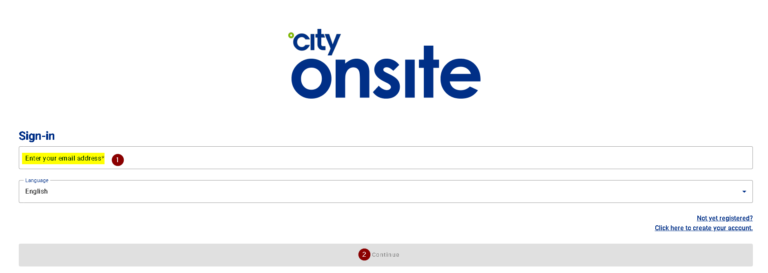  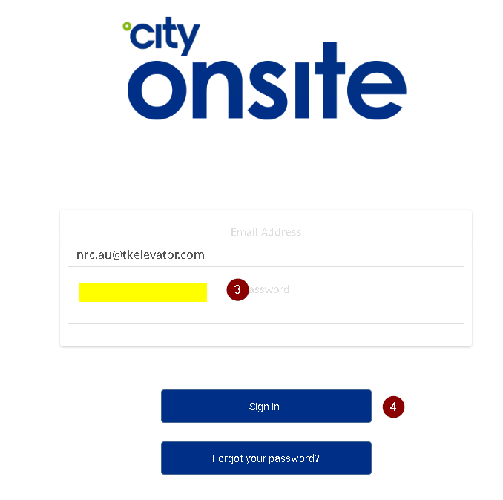  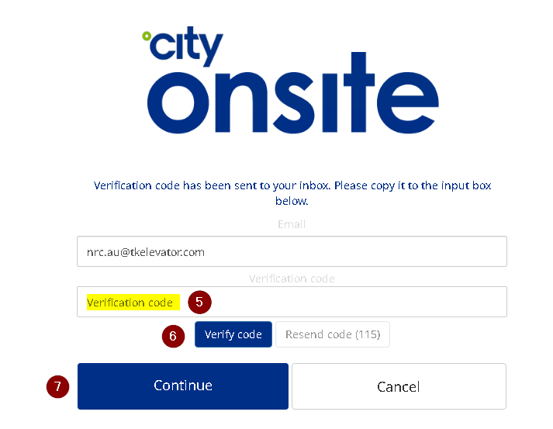  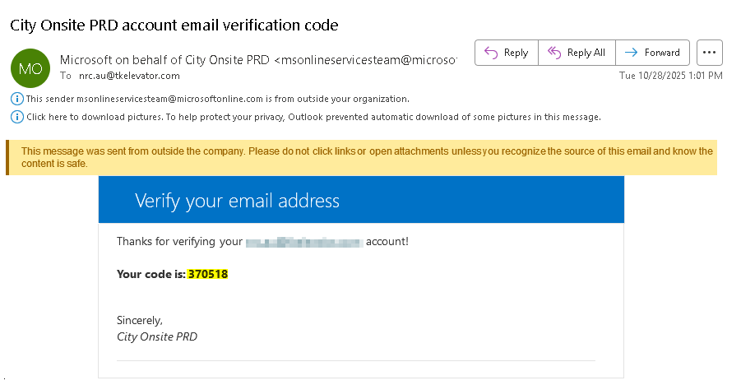
Condition OR  Business Rule | Robot will:  - Enter login account  - Click “Continue” button  - Enter account password  - Click “Sign in” button  - Click “Send verification code” button  - Get verification code by mail  - Enter “Verification code”  - Click “Verify code” button  - Click “Continue” button  *There is a 3rd party MFA verification when login City FM portal, the bot will get the verification code by mail (Use NRC public mail account: nrc.au@tkelevator.com)
Exception | If login failed, robot would send business exception remind mail to RPA support team

Retrieve Operation Data
The robot will retrieve operation data in “Open Jobs” module:
Step ID | 002
Key stroke level steps | 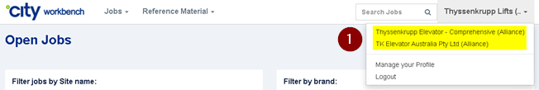  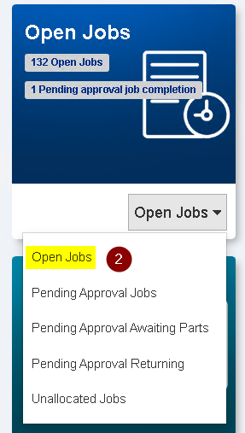  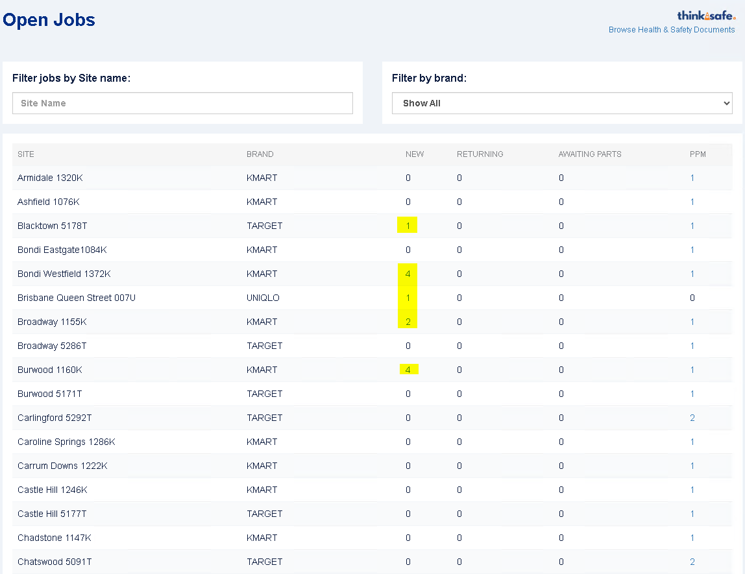  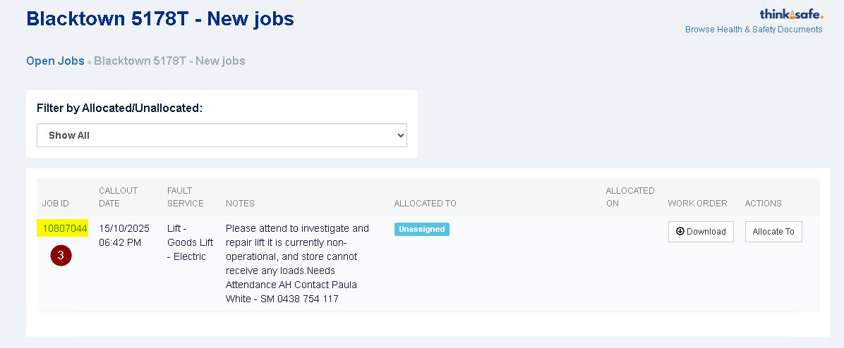
Condition OR  Business Rule | Robot will:  - Switch menu category:  - TK Elevator Australia Pty Ltd (Alliance)  - Thyssenkrupp Elevator - Comprehensive (Alliance)  - Click the link which has data items in “New” column for per item  - Get “Job ID” for per item and storage to transaction data table  City FM URL: City FM
Exception | N/A

Get Docket Information

Login to VIEW Platform

The robot will login to VIEW platform:
Step ID | 003
Key stroke level steps | 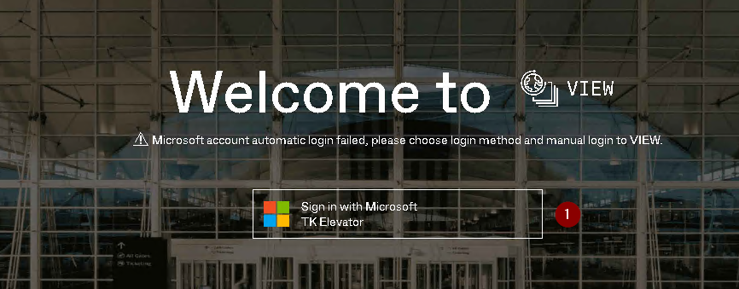
Condition OR  Business Rule | Robot will:  - Login View via Microsoft account (service account)  VIEW URL: VIEW Platform for ANZ
Exception | If login failed, robot would send business exception remind mail to RPA support team

Search Docket
The robot will search docket in “Log a Call” module:
Step ID | 004
Key stroke level steps | 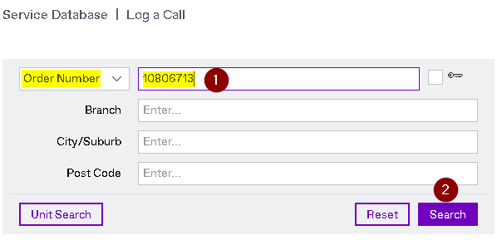
Condition OR  Business Rule | Robot will:  - Search docket by “Order Number”  (Job ID source from previous step)  - Click “Search” button
Exception | If the docket cannot be searched by “Order Number” (Job ID), robot will record business warning message in execution summary report file  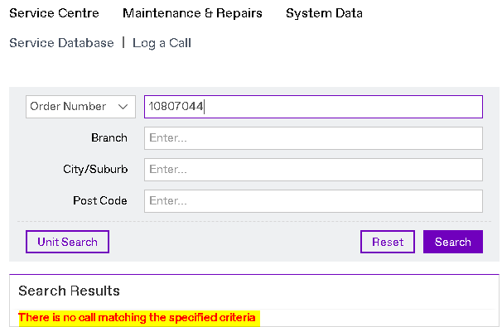

Download Docket Document
The robot will download docket document:
Step ID | 005
Key stroke level steps | 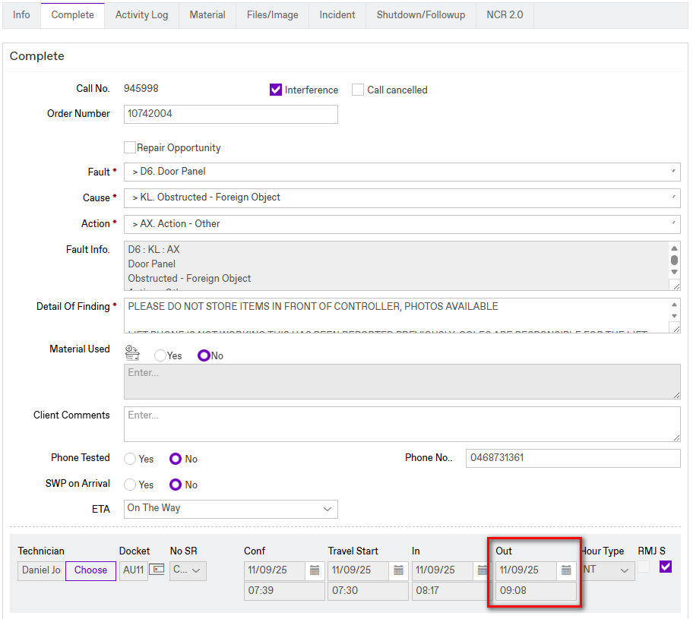  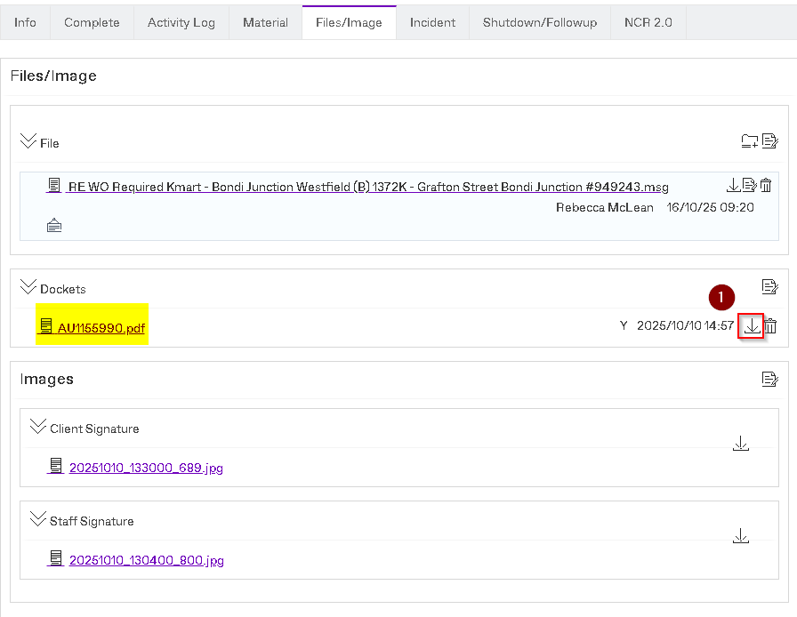
Condition OR  Business Rule | Robot will:  - Check if the callout is completed  - Check the “Time Out date and time” field in Callout Complete Page.  - If a Time Out date/time is present, the bot will navigate to “Files/Image” tab and click icon button  - Save the docket document to local
Exception | If no docket document attached, robot will record business warning message in execution summary report and skip to next transaction item

Get Key Information from Docket Document
The robot will get key information from docket document:
Step ID | 006
Key stroke level steps | 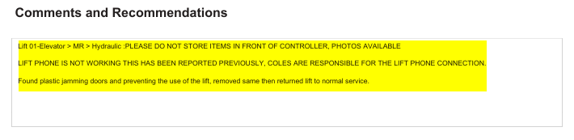  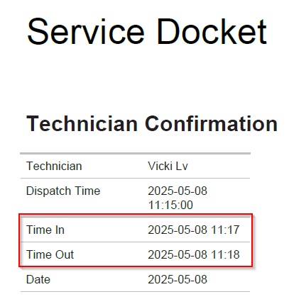
Condition OR  Business Rule | Robot will:  - Get “Comments and Recommendations”  - Get “Dates” info (Time In and Time Out)  *In second page of docket document
Exception | N/A

Maintain and Complete the Work Order

Work Order Maintenance (City FM)
The robot will maintain related information in Work Order details page:
Step ID | 007
Key stroke level steps | 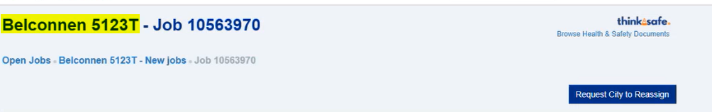  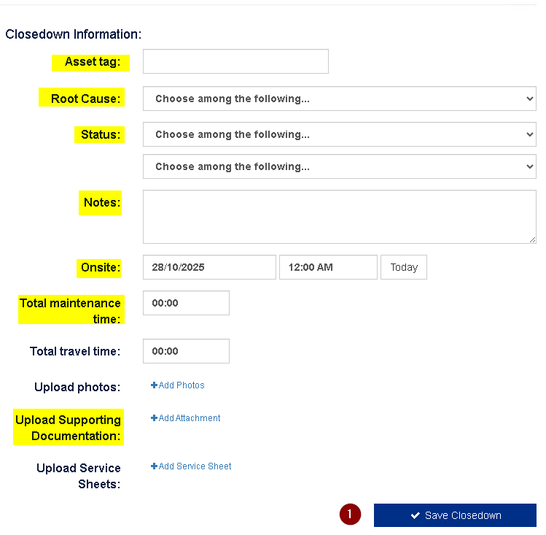
Condition OR  Business Rule | Robot will:  - Maintain related information in Work Order details page:  - Asset tag: Get key information from header and  mapping with corresponding asset tag  - ACT Branch Asset Tag Mappings  Bega 3304K 42646649  Belconnen 5123T 42646644  Gungahlin 1245K 42646645  Goulburn 5122T 42646681  Wodonga 1238K 42648913  - Other Branches Asset Tag Mappings  -find specific Asset Tag by mapping both Column C and Column F  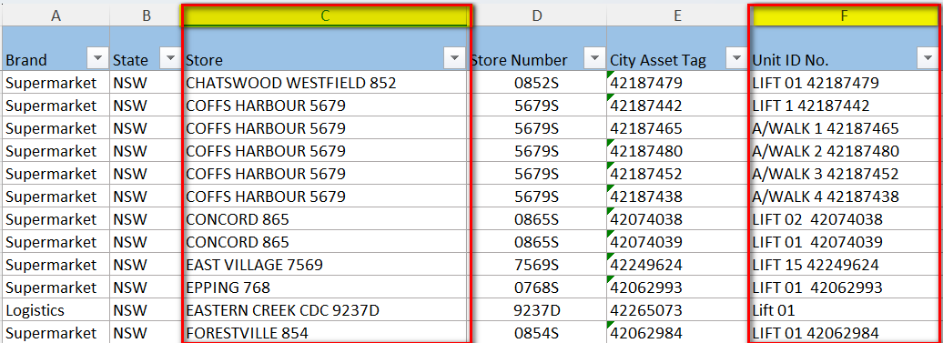  - Check “Assign this asset to the closedown”  - Root Cause: Wear and tear  - Status: I’m complete – if any key words ‘Lift returned to service; No faults found; Running on arrival; RTS’ in Comments and Recommendations.  “Returning” & “Awaiting Parts”  *Robot will refer to the actual value maintained by end users  - Notes: Comments and Recommendations (Get from  docket document)  - Onsite: Time In (Get from docket document)  - Total maintenance time: Time Out-Time In (Get from docket document)  - Select “No” option of “Is this job raised as a result of works identified during a PPM?”  - Upload Supporting Documentation: Docket document  - Click “Save Closedown” button
Exception | N/A

Execution Report & Remind Mails

Generate Execution Report
The robot will generate execution report for all operated data:
Step ID | 008
Key stroke level steps
Condition OR  Business Rule | Robot will:  - The execution summary report will be generated when the process executes completed  - There are 3 execution status:  - Success  - Warning (With business exception)  - Failed (With system exception)  - The file name should be  “Customer Docket Execution Summary Report (yyyyMMdd).xlsx”
Exception | N/A

Success Remind Mail
Robot will send success remind mail if the process executes without any errors:
Step ID | 009-01
Key stroke level steps | 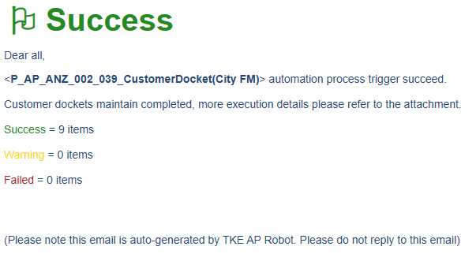
Condition OR  Business Rule | Robot will send success remind mail:  - Mail Subject: [RPA-Success] Customer Docket (City FM) - Execute Success  - Attachment: Customer Dockets Execution Summary Report (yyyyMMdd).xlsx  - To:  Brisbane Office brisbane.au@tkelevator.com;  Melbourne Office melbourne.au@tkelevator.com;  Adelaide Office adelaide.au@tkelevator.com  McLean Rebecca rebecca.mclean@tkelevator.com;  Canberra Office canberra.au@tkelevator.com;  perth.au@tkelevator.com;  sydneyadmin.au@tkelevator.com  - Cc: RPA support team
Exception | N/A

Business Exception Remind Mail (No Operation Data)
Robot will send business remind mail if no operation data:
Step ID | 009-02
Key stroke level steps | 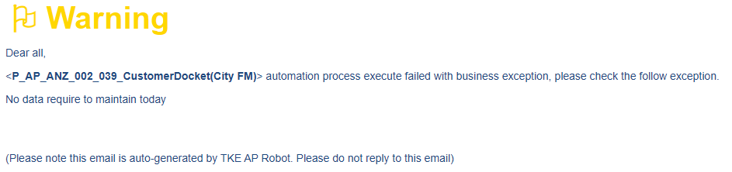
Condition OR  Business Rule | Robot will send business exception remind mail:  - Mail Subject:  [RPA-BusinessException] Customer Docket (City FM) - No Data  - To:  Brisbane Office brisbane.au@tkelevator.com;  Melbourne Office melbourne.au@tkelevator.com;  Adelaide Office adelaide.au@tkelevator.com  McLean Rebecca rebecca.mclean@tkelevator.com;  Canberra Office canberra.au@tkelevator.com;  perth.au@tkelevator.com;  sydneyadmin.au@tkelevator.com  - Cc: RPA support team
Exception | N/A

Business Exception Remind Mail (Others)
Robot will send business remind mail if process executes with business exception:
Step ID | 009-03
Key stroke level steps | 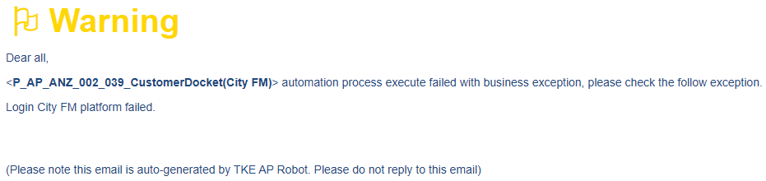
Condition OR  Business Rule | Robot will send business exception remind mail:  - Mail Subject:  [RPA-BusinessException] Customer Docket (City FM) - Execute With Business Exception  - To: RPA support team  - Cc: N/A
Exception | N/A

System Exception Remind Mail
Robot will send system exception remind mail if no operation data:
Step ID | 009-04
Key stroke level steps | 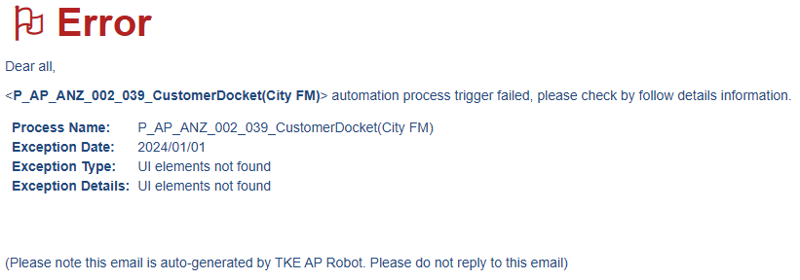
Condition OR  Business Rule | Robot will send system exception remind mail:  - Mail Subject:  [RPA-SystemException] Customer Docket (City FM) - Execute With System Exception  - To: RPA support team  - Cc: N/A
Exception | N/A

Exceptions

Business Exceptions
  - If Customer portal login accounts expired, robot will send a business exception mail to RPA support team
  - No data require to operate, robot will send a business exception mail to key users and cc RPA support team
  - If no docket document file attached, robot should record the message in execution summary report
*Robot will ignore the item that occurred business exception and skip to next transaction item

Technical Exceptions
- If the operation element not found, robot will record error message to “Customer Docket Execution Summary Report (yyyyMMdd).xlsx”
- If there is a delay in logging web applications, robot will retry 2 times (interval 1 min)
*Robot will retry 2 times for the item occurred system exception

Additional Comments
- City FM URL: https://app.cityonsite.com/
- VIEW URL:
  - Docket search
    - DEV2: https://audev2.fos.tkeasia.com/sharp/call/docketsearch
    - Pro: https://au.fos.tkeasia.com/sharp/docketsearch
  - Log a call
    - DEV2: https://audev2.fos.tkeasia.com/sharp/call/buildingsearch
    - Pro: https://au.fos.tkeasia.com/sharp/call/buildingsearch
- SharePoint URL:
https://tke.sharepoint.com/sites/tkeauteamsites/CallCentre/NRC%20Admin/CityFM
- Key Users Mail Group - ACT: canberra.au@tkelevator.com
- Key Users Mail Group - Others: Brisbane Office brisbane.au@tkelevator.com, Melbourne Office melbourne.au@tkelevator.com; Adelaide Office adelaide.au@tkelevator.com McLean, Rebecca rebecca.mclean@tkelevator.com; Canberra Office canberra.au@tkelevator.com; perth.au@tkelevator.com; sydneyadmin.au@tkelevator.com

SOD Conflict Checks

Evaluate SoD on process level
Evaluation Check points | Response
Does the process being designed affect one of the attached systems? If not, no further checks are needed. If yes, please consider below questions. | N/A
In the relevant system, does the process include more than one activity (e.g., more than one T-Code being executed in SAP environments)? If not, no further checks are need. If yes, please consider below questions. | N/A
Are the performed activities related to the modification of data or is it read only activities? If none or only one activity is modifying data, no further checks are need. If it is two or more activities, please consider below questions. | N/A
If two or more activities are related to the modification of data, please list these activities and contact the respective system owner for conducting simulations and confirming that the activities are conflict free. | N/A

(Note: The confirmation of the system owner and SoD simulation result should be attached.)

Evaluate SoD between process and requestor.
Evaluation Check points | Response
Does the requestor of the process have access to the same (relevant) system in which the process is operating? If not, no further checks are needed. | N/A
Does the requestor have the same access rights as used in the process? If yes, no further checks are needed. | N/A
In case of different or additional access rights, please list them and contact the respective system owner for conducting simulations and confirming that the activities are conflict free. | N/A

(Note: The confirmation of the system owner and SoD simulation result should be attached.)

Result
Evaluation Result | Response
Is the Process SOD conflict-free (also in combination with the requestor’s access rights in the target system)? Yes/No/NA (For non ICS critical applications.) | N/A

Flowchart of 9.1 for better understanding:

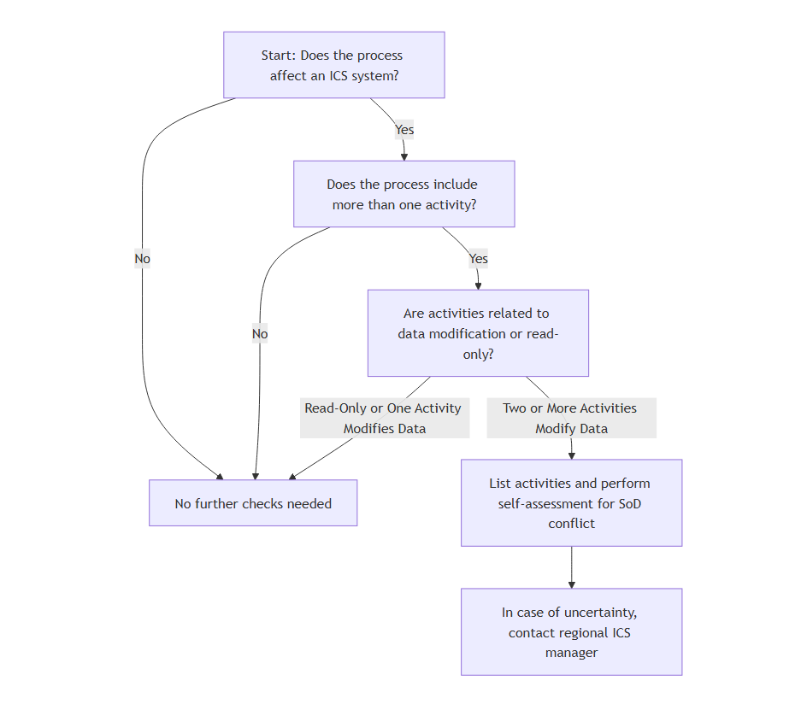

Glossary of Terms
Term/Acronym | Description
BA | Business Analyst

Approvals

RPA Process Owner (Adsul, Santosh) Date

RPA Service Owner (Lin, Yijia) Date

